Holy Island: Around the Island
Allow 2-3 hours or even longer to allow pause-and-reflection time.

The Walk starts at the car park on the outskirts of the village. If you come on a coach, head back up to the road, turn right and walk to the car park. Spend a short time preparing for the Walk – perhaps by the benches at the pedestrian gate. Give yourself a few moments to breathe deeply of the clean air – and allow your soul to catch up.

Turn right along the road and then right again into the wildlife area.
Look at the plants in all their variety – “Consider the lilies of the fields...” Take time to look – touch – smell – but leave them for others to enjoy.
Look for birds – listen to their songs – “Our Father notices each sparrow that falls…”
You may hear skylarks – a group of them is called an exultation! As you listen to their exultant singing, allow their song to help you to exult in God who created them.
+

Through the Dunes
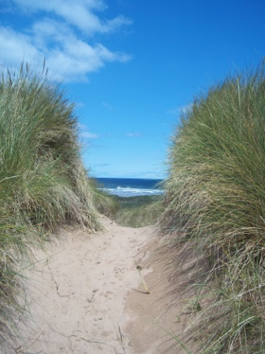
Keep heading towards the dunes. As you enter them, be aware of their barrenness – the wilderness – the many paths that people have made through them. It is hard to give directions at this point but choose paths going “straight ahead” – aiming for the northern coast.
As you choose – and wonder whether you are on the best path – think about how it might reflect your life… you know roughly where you are going but it can be sometimes tricky to find the most direct route to it!

Listen for the sea to help to direct you (this may depend on tides and winds).
Reflect on how often we sense things and move towards them even if we cannot see them.
+
Along the Coast
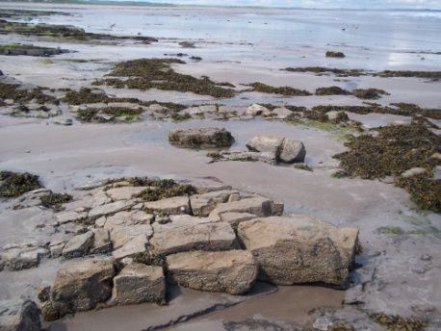
When you come to the sea, turn right and either walk along the sand (if safe to do so) or along the top of the dunes alongside the beach.
Drop down to the limestone pavement where you can.
Think about the millions of years that this rock has taken to form – and here you are upon it.
Notice how, though it is entirely natural, it looks almost as if it could be human-made.

You may see oyster catchers – eider ducks – and other wildlife.
Take time just to watch and savour them getting on with their lives – heedless of so many things that trouble us.

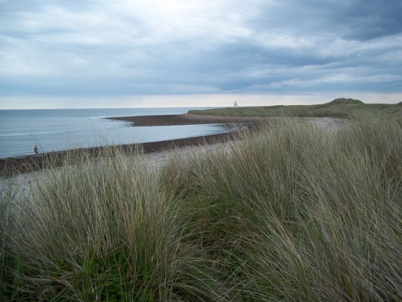
Follow the coast round towards Emmanuel Head – marked by the triangular building just visible on the horizon in the photo.
Spend time on the Head.
Look at the sweep of the sea around you – and feel its vastness.
If visibility is good, look north towards Scotland – and south towards Bamburgh.
Think back to the conflicts in this part of the world – why there are so many castles. Give thanks that this is now a place of peace and tranquillity.

Follow the coast again – aiming for the Castle.
If the tide permits, head onto parts of the beach. You may well find flotsam and jetsam – bleached bits of wood – litter from picnics or ships…
Think about how the sea deposits this on the shore… and about what is the flotsam and jetsam of your own life.

Head back to the path (or continue along it!) – up to the sign posts. You now have a choice – turn right on the public right of way to the village or carry on further towards the Castle.

[Short cut to the Village
Turning right – you will probably go between fields with sheep in them. Spend time watching them and ponder Jesus calling himself the Good Shepherd.
What does that title mean to you – when few of us have met a shepherd? What do the sheep teach you about what it might mean?

Follow the track into the village – and find a suitable refreshment spot before enjoying the rest of your time and returning to the car or coach.]
+
Towards the Castle
Look left towards the islands (the Farnes) – and look for the flashing lighthouse. This is Longstone Rock where Grace Darling lived and from where she mounted her rescue.
Look at the sea and imagine it in all its moods… perhaps calm as you look at it – or perhaps hinting at storminess. Reflect on the work of the lifeboats and people who risk their own lives to save others.

If you follow the path closest to the shore, you will come to the field of stone sculptures – where people have created towers and pictures using the stones lying around. You may like to play yourself! Or simply admire the creativity of the others.
Reflect on how temporary your creation will be compared to the great age and powerful forces of nature that created the stones you are using.

[Option – visit the Castle and Lime Kilns
Follow this path – or the one slightly higher – and head on to the Castle. At the bridge, you may decide to visit the Castle – or go under the bridge to look at the Lime Kilns.]

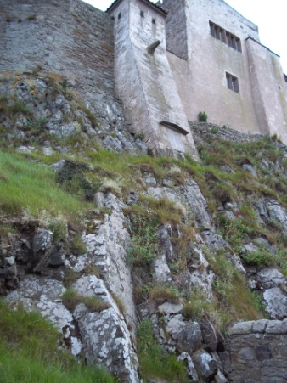
If you carry straight on, look up at the Castle built on rock.
Think about the some of the words we use about God: O God you are my Rock… you are my refuge… my high tower… my fortress… How does the Castle help you to understand the meaning of those ways of describing God? Can you think of others?

Follow the road and look over to the Priory Ruins – recalling the important part prayer has played on this Island.

Continue on into the Village or turn left and walk past the upturned boats used for storage. You may also see fishermen busy about their work.
Reflect on Jesus choosing fishermen as his first disciples… men such as these busy with boats and nets and what it cost them and their families when they left their nets and followed him…

You may choose to go up the Heugh on the left.
At the top, there is a war memorial.
Remember here the cost of more recent conflicts even in this peaceful place.
It is possible to cross the Heugh and scramble down the other side – or retrace your steps and take the path that skirts the hill to the right.

[Short cut to the Village
Go through the turnstile gate and head across the field to the village…
Take time to pause as you go to ponder the ruins of the Priory on your left.]
+

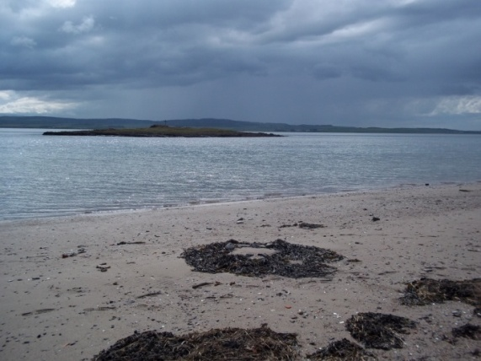
St Cuthbert’s Island
Follow the path or shore round to St Cuthbert’s Island – the small island that is cut off from Lindisfarne at high tide.

Look over to the mainland where you can just see the A1 traffic and the main east coast railway. Reflect on the contrast between the stillness you are experiencing and the busyness of travel in everyday life. Give thanks for this time of respite – and pray for those whose work on the roads and railways bring food and other goods to our homes and families.

Depending on the tides, watch as the sea recedes and then cross the beach and pick your way among the stones to Cuthbert’s Island. (Do NOT do this if the tide is coming in as you will have a long wait to get off again!)
Enter the ruins of the building and imagine spending time here. Listen to the sounds of the sea – the birds – the seals – the people in the distance. Watch the clouds as the weather moves (usually but not always from the mainland). Touch the stones and plants…
Simply “be” as present to the experience as you can – reflecting back over the centuries to Cuthbert’s time on this holy ground.

St Mary’s Church
Make your way back across the beach and head up towards St Mary’s Church. Walk around it to the right to the door. Before you enter, pause and remind yourself that this church may be built on St Aidan’s original foundation. This part of the Island has been a place of prayer for over 1400 years – and here you are today, continuing that tradition. Enter the church and spend time looking at the things around you… from Fenwick Lawson’s Journey of Cuthbert to the embroidered carpets. (A more detailed prayer time in the church is described here – plan is to do a “Trinity of Churches” walk)
It is usually possible to light a candle before the Icon of Mary (who is the patron of the church) and Jesus. As you light it pray for the witness of faith of this place over the centuries.

Leave the church and turn left towards the Priory. If you wish to go into the Priory and don’t have English Heritage membership, you will need to continue past the gate to buy a ticket in the shop. If you go in, reflect on the work of those who built it. Make your way round to the sculpture of St Cuthbert and spend time allowing the stillness of the image to speak to you. (More ideas for reflection in the Priory can be found…)
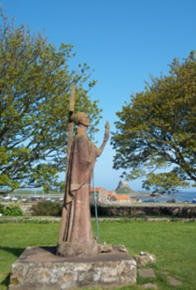

Outside the Priory itself is a statue of St Aidan bearing the torch of faith.
Spend time by the statue reflecting on how this man – and countless other unnamed men and women made their homes and prayer-spaces on the Island – and how they made Lindisfarne the Cradle of Christianity.

+
Into the Village
As you leave the church and Priory complex, you might like to call into the exhibition in the English Heritage building.
Opposite the building, you will see a list of the launches and rescues of local lifeboats.
Pause to look at them and, again, reflect on the courage and selflessness that leads people out into stormy seas to rescue those in peril. Pray for them.
Reflect on ways in which you might be called to go out to those whose stormy seas are different…loss, unemployment, addictions – and more… Pray for similar courage.
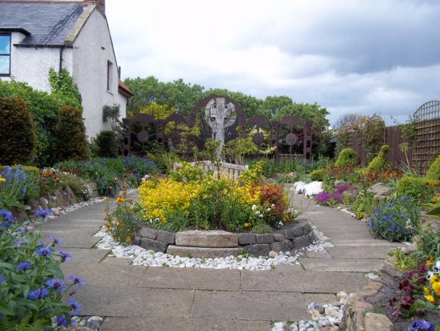
Continue along the road as far as small “square” and turn left. You may wish to visit the Heritage Centre on the left of the street and learn more of the history of the Island and the story of the Gospels. Opposite the Centre is the Island’s “Gospel Garden” based around the theme of the Lindisfarne Gospels.
Spend time enjoying the stillness and looking out for the details that speak of the Lindisfarne Gospels.
Turn back towards the village and turn left.

A little further on, on the left, you will see the Lindisfarne winery and beyond that St Cuthbert’s Centre. This has a selection of other walks. Take a few moments to walk around the back to the tiny Boiler Room Chapel. If in a group of more than two, take turns to spend time in prayer there.

Back to the main street, pause at the Marygate and Open Gate retreat houses on the road to your left.
Pray for the many people who come to the Island for a time of retreat and renewal.

Turn right and continue straight down the road towards the Castle (though you won’t be going back there!) On the left, you will come to the Lindisfarne Scriptorium… if it is open, pop in and see how the long tradition of illuminating manuscripts is continuing to be developed.
Continue to the end of the road – turn left and then left again to go past the coach park.
Here again, pause to think of the many groups who come to make a pilgrimage to this holy place.

Continue up the road. Just past the coach park you will see an entrance into St Vincent’s Camp which is used to offer children from deprived areas a chance of a holiday.
Pray for the children and the volunteers who give their time so that they can have a great time – and feel something of the love of God through the beauty of their surroundings and the love of the people who care for them.
A little further up is St Aidan’s church on the right. This has recently been refurbished and offers a beautiful place to stop and gather up your remaining energies for the walk back to the car park (unless, you started at the coach park, of course!)
In the quiet of the church, look back over your walk… what stands out for you?
What “station” or stopping place seemed to be particularly blessed for you?
Were there any challenges along the way?
What would you like to give thanks to God for from this Prayer Walk around his Holy Island?

+

We hope that you have enjoyed the Walk.
Please let us have any comments or thoughts that might be of help to future Prayer Walkers.
Contact: kathryn.turner@diocesehn.org.uk

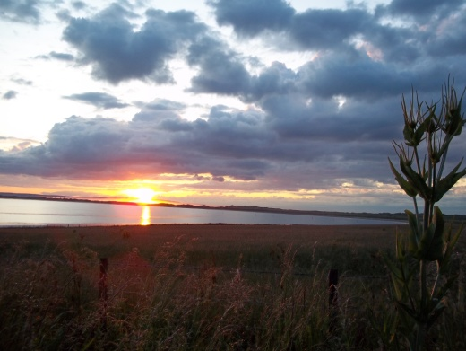

Text © 2012, Diocese of Hexham and Newcastle
Photographs © Kathryn Turner

