Preparing to arrive on Holy Island

On foot
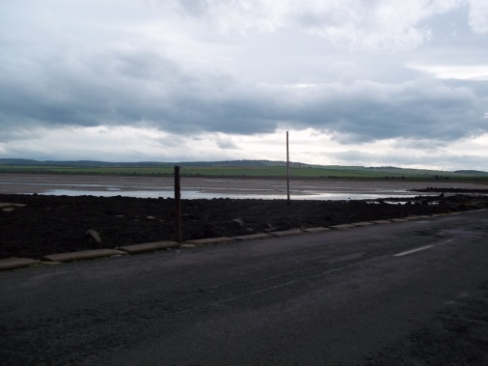
You may choose to walk the Pilgrim Path across the sands. Choose your time very carefully and, if possible have someone with local knowledge walk with you.
Before you start – look towards the Island and reflect on people such as Aidan and Cuthbert and the countless men and women who have stood where you stand and prepared to make the journey you are going to make.

How does it make you feel to be walking in the footsteps of those Northern Saints?

By car
If you are arriving by car, stop just before the causeway (there is a car park just on the left). Get out and look ahead to the journey that will take you across part of the North Sea. Be aware of the power of the sea that covers this Causeway twice a day. Make sure you respect the tides and know what time you need to leave – please do NOT be one of those who have to be rescued! Check the Safe Crossing Times
+

