The Walk – Marsden Bay

Kathryn Turner writes; the walk starts at the Souter Lighthouse and takes you along the coast along Marsden Bay. It is a fairly level walk on paths and grassland and offers a chance to reflect on earth, sea and sky.

Allow 1 hour or longer to allow for pause and reflection time. There are regular buses from South Shields and Sunderland.

Click here for information on Souter Lighthouse and Marsden Bay.

Ordnance Survey Maps – Explorer 316 / Landranger 88: Reference NZ408642 or link to Google maps.

----------------------------------------------------------------------------------

From the car-park walk around the lighthouse to the information boards near the tearoom and toilets. Read the notices that speak of the fragility of the local landscape and keep this in mind and heart as you take this Prayer Walk.

As you start the walk, pause to reflect on the words from Proverbs (8: 22-30) which remind us of the great age of the earth – and that God was there before its beginning. Try to hold them in your mind and heart as you go take the Walk.

Ages ago I (Wisdom) was set up,
at the first, before the beginning of the earth.
When there were no depths I was brought forth,
when there were no springs abounding with water.
Before the mountains had been shaped,
before the hills, I was brought forth—
when he had not yet made earth and fields,
or the world’s first bits of soil.
When he established the heavens, I was there,
when he drew a circle on the face of the deep,
when he made firm the skies above,
when he established the fountains of the deep,
when he assigned to the sea its limit,
so that the waters might not transgress his command,
when he marked out the foundations of the earth,
then I was beside him, like a master worker;
and I was daily his delight,
rejoicing before him always.

Head towards the sea and left along the coast path. Spend a few moments looking at how earth, sea and sky come together in this place… of the cliffs and beaches meeting the sea – and the sea and sky meeting at the horizon.

Walk around Lizard Point. The car park is closed due to erosion of the land under the cliffs. Look along the coastline and consider its beauty –but also its fragility… though it looks permanent, it will not always look like this.

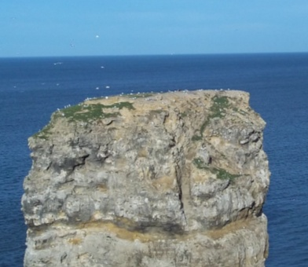
Head across the grass towards Marsden and stop to look over towards the rock-stacks that are home to cormorants, kittiwakes, black-headed and herring gulls and fulmars. Spend time watching them soar on air currents – floating on the sea – or walking on the beach or grass.
Reflect on these ‘birds of the air’ – how they are at home on earth, sea and sky in ways that humans cannot match.

Read the notice about Marsden Rock and the effects of frost, wind and sea – and again, reflect on how sea and air (in the form of wind) affect the seemingly permanent earth. Sometimes their work is dramatic and aided by human activity. More often, their work will take years but gradually they change the landscape.
What are the equivalent of the sea and air in your life? Perhaps think of the sea as the waters of your baptism – how has this shaped the landscape of your life? And the air – the wind – as the Holy Spirit… how has this blown through you and changed you?

As you walk, you may be aware of planes coming into Newcastle Airport. Watch how they come out from the land to fly over the sea and follow the coastline… they will turn west to make their approach by the white lighthouse (St Mary’s at Whitley Bay) that you can see in the distance.
Pray for the crew and passengers and ponder the purposes of their journeys – for pleasure – for work…

As you look ahead, you may see two lighthouses – with Souter and Roker behind you.
Remember the people who staffed the lighthouses in all weathers and saved the lives of so many mariners. Pray for those who carry on that work today.

At Marsden Grotto, you can take the lift down to the café/bar and beach – or use the steps alongside – or continue along grassland of The Leas.
If you go to Marsden Grotto, read about the ingenuity of the people who carved out the caves to make a living there.

If the tide is out, you might like to pick your way over to the Marsden Rock (do NOT do this if the tide is coming in!) Look in any rock pools. Marvel at the arches carved out by the sea.
Walk further along the beach. Pick up pebbles and stones worn smooth by the action of the waves…
How does God work in your life to wear away your rough edges? Where does God still have work to do!

Walk as far along the Leas – along the beach or grassland – as feels comfortable (this will probably take you over the hour suggested for the Walk).

Return along the same path – and notice how things might look different from this direction.
Ponder how sometimes we need to see things from two perspectives – different viewpoints – in order to see a bigger picture and, perhaps, make a better decision.

Some of the land-slips are easier to see going in this direction – ponder again the relationship between land, sea and air… how each affects the other

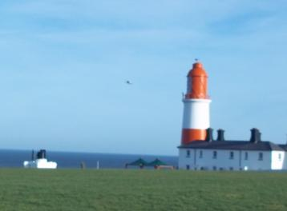
As you approach Souter Lighthouse, notice the large foghorns pointing out to sea. If you time your visit right, you may hear them.
Reflect on the warning sounds piercing the fogs. It may seem a bit disrespectful but think about some of the prophets who called their warnings into the fogs of confusion and unfaithfulness… and those who continue to do so in our day.

As you make your way back to the car-park or bus-stop, reflect on your Walk.
What were any highlights?
Did anything surprise or captivate you?
What thoughts or particular memories do you take back with you?

Text and photographs © Diocese of Hexham and Newcastle

