Simonside - The Walk

Kathryn Turner writes; the walk takes you through woodland with options to scramble up Simonside and/or extend the walk to see Neolithic carvings near Lordenshaw. It is a fairly strenuous walk on paths and grassland with a couple of steep climbs. Allow three hours or more for the ‘full’ walk or even longer to allow for pause and reflection time.

The closest village is Great Tosson near Rothbury. OS Maps Landranger 81, Explorer OL42: Reference NZ 037 997. Google Maps location. Sat Nav Postcode: NE65 7NW.

There are buses from Rothbury and Morpeth, but on Sundays and Bank Holidays from Newcastle and Gateshead.

Click here for more information on Simonside.

--------------------------------------------------------------------------

The walk starts at the main car-park. With the board facing you, take the path to the right (the route has red waymarks for most of the way – which helps!)

Head up through the conifer plantation and note the sights – sounds and smells as you pass through the woods

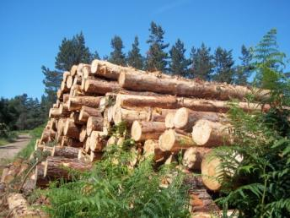
You might consider wood as a renewable resource – here, well-managed and sustainable. Think also about wood as a resource which is being depleted in other countries. For example, the poor in Africa cutting wood and having further and further to go to collect it – and the desert encroaching on wood and scrubland. In other countries, virgin forest is being cut down to harvest the wood and clear land for farms and cattle grazing – land which is soon lost without the tree cover that has protected it from rains and wind for thousands of years.

Give thanks for the beauty of the woodland – and pray for wise management of woodland resources in other parts of the world.

As the path meanders uphill, you will go past a TV transmitter. Reflect on how television can also be well or poorly managed. What messages do they pass on to the public? Pray for those in the media that the messages will be life-giving and informative rather than simply focused on scandal and celebrity.

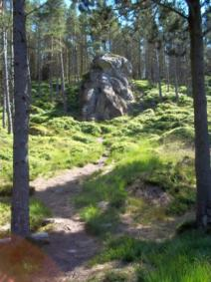
The track bears left and, after going through a barrier, look for a path signed to Little Church Rock. Follow the path and come to the Rock which was used as a “Little Church” for services by people whose worship was forbidden by the established church – Catholics and some Protestant denominations.

Pray for those who prayed here long ago – and pray for tolerance and freedom to worship – particularly in parts of the world where Christians are persecuted.

Return to the main path and turn left to follow it through the trees and into a narrow path that seems almost to have been carved from the rocks.

This may encourage you to think of passing through narrow gates! Reflect on the wide path behind you and the narrowness and unevenness of this cutting and reflect on Jesus contrasting easy and difficult ways to heaven.
As you move from the trees, you will move onto more open ground and see the rock-face of Simonside. At this point you may decide to take the lower path and return to the car-park.

Lower path
As you walk along the path, look at the solidity of the rock face and ponder these words from Psalm 18
I love you, O Lord, my strength.
The Lord is my rock, my fortress, and my deliverer,
my God, my rock in whom I take refuge,
my shield, and the horn of my salvation, my stronghold.
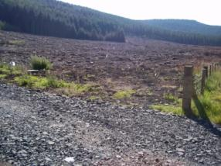
You may also walk through cleared land which can look like a battle-field… this may raise echoes of Ezekiel looking at fields of dead bones and hearing God’s promise to breathe new life into them.

Pray for those who care for the woodland and who ensure that the earth’s resources are well-stewarded in order to remain productive.

When you return to the car, you may like to head back towards Lordenshaw and pick up the extension to the “Cup and Ring” rocks. There is a car park and signs to the various rocks and carvings…. see below.

Higher path
As you prepare to scramble up the hill. pause to think of characters in the Bible who also went up hills and mountains… Moses – Elijah – Jesus. There is a tendency to think that they simply arrived at the top – this climb may remind you that they did not!

As you climb, reflect on the difference it makes to remember that their mountain-top experiences were probably arduous too.
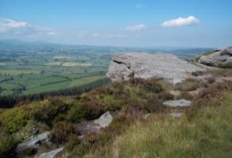
At the top, spend time reaping the reward of the spectacular views across Northumberland. Take time to appreciate why this site has been sacred to people for thousands of years.

Follow the flagged path – this is very easy to follow and will take you down to the road.

Pause often to note the changing views – notice the changing flora – and try to spot some of the wild goats who live in the area. When you notice something, remember to give thanks for the gift God has prepared for you and all who pass this way. You may also wish to give thanks for the huge amount of labour that went into creating the path which protects the environment and allows thousands of people to enjoy it.

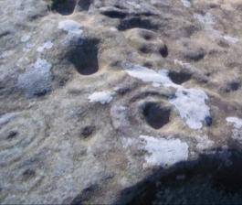
At the road, you may decide to turn left and head back to the car-park. Alternatively, cross the road and car park opposite and investigate the ancient “Cup and Ring” carvings and hill fort.

Here too is evidence that this has been a special place for thousands of years – possibly a religious site –though we have no idea what form that religion took.

Pray for all who are searching for the truth and spiritual enlightenment. Pray for those who help them to find it in the person of Jesus Christ.

How might others view some of the things we say or do – and how can we help them to understand their meanings?

Return to the road and turn right to head back to the car park.

As you return, reflect on your Walk.

What were the highlights?

What was most challenging?

What lasting impression will you take home with you?

Text and photographs © Diocese of Hexham and Newcastle

