The Walk – Souter Lighthouse

Kathryn Turner writes; the walk starts at the Souter Lighthouse and takes you along the coast, up through countryside following parts of ‘Bede’s Way’ with panoramic views across Gateshead and towards Newcastle (on a clear day!) and back along the beautiful Marsden Bay. It is a moderate walk with some stiles and climbs. Allow two hours or more to allow for pause and reflection time.

Regular buses are available from South Shields and Sunderland.

Click here for information on Souter Lighthouse and Marsden Bay.

Ordnance Survey Maps – Explorer 316/ Landranger 88: Reference NZ408642 or view in Google maps.

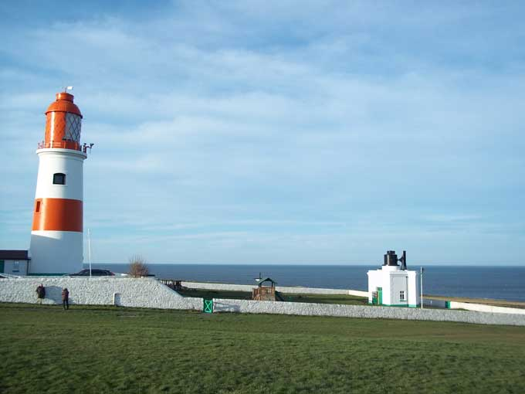
---------------------------------------------------------------------------------

From the car park head towards the sea and walk along the coast path. As you start the walk, pause to pray the words: Lord, teach me your ways – show me your paths.

Just past The Wherry (marked) take the path to the right climbing to a small gate. At the junction look back – and see a view you might have missed had you just pressed on.

Often, it is only when we look back we see things as they really were – or see beauty that may have passed us by in the busyness of life. When has this happened to you? Spend a few moments remembering and giving thanks.

Follow the path up and to the right – perhaps dropping down to the newly-built hide overlooking a reed bed and then back to follow a path lined with memorial benches.

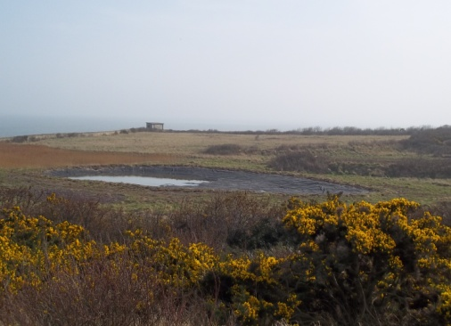
As you pass, ponder the stories of the lives recorded here. Pray for those who have died – particularly those who have no known resting place – and those who mourn them.

This picture was taken of the pond in March 2012 – it was almost empty after a dry winter when drought was declared in parts of England.

Reflect on the preciousness of water – of places where people walk miles to collect it – and of what life is like for those who cannot just turn on a tap.

Drop down and take the track to the right and at the end of the bushes, bear left towards the houses and then right towards the main road. Turn left and go past the local school…

As you pass pray for the staff and children and their families.

Cross the road and take the first path into the windmill grounds and head up the slope. You are aiming to keep straight ahead (though will have to follow the roads between houses!) When you get to the road, you are aiming for a bus-stop next to house number 99 where you will find a path. Follow this and, at the end, turn left, cross the road and follow a footpath next to the first bungalow.

Walk along the farm track – you are now following part of ‘Bede’s Way’ that links St Peter’s in Wearmouth and St Paul’s in Jarrow. No-one knows whether the monks would have walked this way but we are certainly walking in their spiritual footprints.

As you walk – and look over at the views, reflect on the fact that you are walking in the footsteps of countless others – and that others will walk in yours. What changes have there been in the landscape – and what might they look like in years to come?

At the end of the hedge, you will find a stile – marked footpath and ‘Bede’s Way’. Cross the stile and follow the path along the edges of the fields – basically along and left and marked with ‘Bede’s Way’ signs at the gates and stiles.

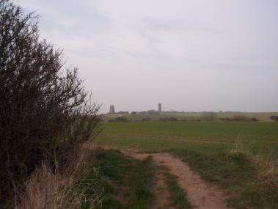
Aim for the disused windmill at the top of the hill. This could be a good place to stop – you will see dog-walkers and possibly para-gliders.

If you see them, reflect on the courage it takes to launch yourself off into the blue… and how, sometimes, God asks something similar of us.
Where do you find the courage to launch into the unknown?

Take the path to the right of the windmill and, as you walk, look over to the panorama on your left.

Pause to reflect on the thousands of people going about their daily lives – working – learning – relaxing – suffering… and each one of them loved by God.

Go through the kissing gate – and continue, keeping the wall on your right until you come to a gate. (It looks as if you can’t get through – but you can!) The path will bring you to the golf course – your way across is marked by yellow markers but do keep an eye out for golf balls.

As you walk along the heathland beyond, look to your left and see the Tyne estuary and Tynemouth Priory.
Think of all the ships and boats that have passed along the estuary – and the witness to faith and hope that the Priory offered – and offers – to all who passed it.

Reflect on how our churches might offer a similar witness in our towns and villages.

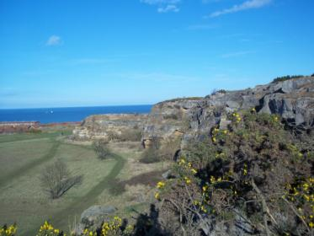
When you arrive at the quarry you can either carry on close to the wall/ hedge on your right or follow one of the paths to the edge – take care! Look down and notice the paths made by local people –how most have followed the most direct route – and how the paths cross. Again, reflect on the lives of the countless people those paths represent.

Reflect on your own path through life – when has it been straight? When have you strayed from the path of faith and love?
Whose paths have crossed yours?

Look also at the rock face – layers of rock laid down over millions of years. Reflect on the age and solidity of the rock – and notice how the plants are changing it – their roots burrowing into cracks and silt and sand building up on the surfaces.

Reflect on the words: ‘Though mountains fall – and hills turn to dust – still the love of the Lord endures. God’s love and faithfulness are for ever.’

Aim for a path at the end of a concrete wall and take the path (with a wall on your right) down towards the road. Cross and follow a bridle-path with the caravan park on your left.

Cross the main road and turn right, aiming for Souter lighthouse.

As you return, think about how this brightly coloured lighthouse is acting as a light to your steps – as it acted as a beacon leading ships safely into port.

Lord, you are a lamp to my feet – you light up my paths.

As you return to the car or bus-stop, look back over your Prayer Walk.

What are you grateful for?

What challenges did you meet along the way – and how did you overcome them?

What memories will you carry from the Walk as you head back to the busyness and routine of daily life?

Text and photographs © Diocese of Hexham and Newcastle

