Woodhorn and Queen Elizabeth Park

Introduction:
This walk is a mixture of a visit to the Woodhorn Museum and a walk, offering an opportunity to reflect on the industrial heritage of our Diocese and the beautiful countryside in which it is set.

Allow 1-2 hours
The walk is level throughout and mostly accessible to wheelchairs and pushchairs.
You can find out more information on getting to Woodhorn and details of their opening times on their website.

As you make your visit, you might like to use words from Ecclesiastes as a recurring theme as you go around.

For everything there is a season, and a time for every matter under heaven:
a time to be born, and a time to die;
a time to plant, and a time to pluck up what is planted;
a time to kill, and a time to heal;
a time to break down, and a time to build up;
a time to weep, and a time to laugh;
a time to mourn, and a time to dance;
a time to throw away stones, and a time to gather stones together;
a time to embrace, and a time to refrain from embracing;
a time to seek, and a time to lose;
a time to keep, and a time to throw away;
a time to tear, and a time to sew;
a time to keep silence, and a time to speak;
a time to love, and a time to hate;
a time for war, and a time for peace.
Ecclesiastes 3: 1-8
Woodhorn Museum - The Walk
Outside the Museum
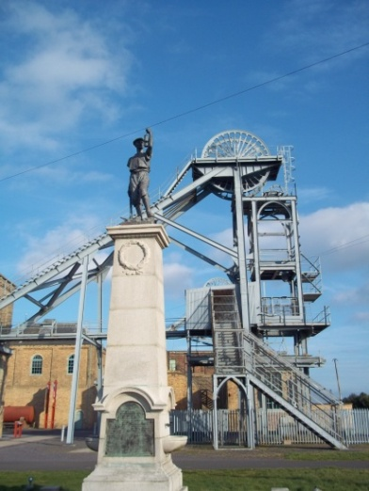
From the car park, head into the complex. Pause to look at the pit wheels.
Reflect on the hundreds of shifts that began and ended in the cages that were winched up and down the shafts, the journey into the darkness, the hard work that lay ahead, or the tiredness at the end of the day, the comradeship, or tension of working in a confined space all day or night.

Stand before the monument to those who died in an accident at the pit.
Pray for all those who have died either in accidents or as a result of long-term illness caused by long years underground.

Find a space and look at the buildings. Try to imagine the busyness of a working pit… the noise… the movement.

How do you feel about the contrast between a working pit and a museum?

Do any of the words from Ecclesiastes help to put your thoughts into prayer?

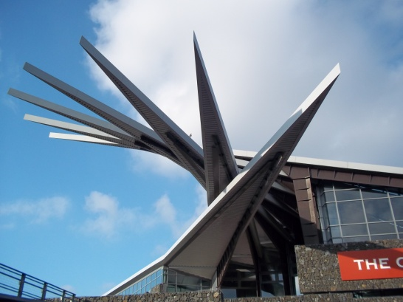
Inside the Cutter
Make your way over to the Cutter. Resist (for a while!) the temptation to go shopping or to the tea room and visit the Exhibition.

Chapter 3 of Ecclesiastes has more thoughts about work. He asks
“What gains have the workers from their toil?”

How would you answer his question from what you see and hear as you go round? Think of the people depicted – of their lives and concerns.

How do you feel as you go round? Does it bring back memories? Or help you to understand some of the family stories?

Another quote from the same chapter:
“I have seen the business that God has given to everyone to be busy with.
He has made everything suitable for its time…”

How does the Exhibition reflect what Ecclesiastes observes here?

Ecclesiastes also says:
“I know that there is nothing better for them than to be happy and enjoy themselves as long as they live; moreover, it is God’s gift that all should eat and drink and take pleasure in all their toil.”

As you go round the Exhibition, reflect on where do you see signs that people were able to enjoy themselves – and eat and drink and take pleasure in their toil?

Spend some time reflecting on the exhibitions about the Miners’ Strike in the 1980s.
What feelings are you left with?

Some families remain broken because of the legacy of the Strike – pray for them. Do any of the words from Ecclesiastes speak to you about what happened then – and what has happened since? Do any other words from Scripture come to your mind or heart?

Upstairs - in the Exhibitions
Visit the Exhibitions upstairs. As these change regularly it is not possible to offer specific thoughts! However, it is likely that you will meet work that speaks of the creativity of men and women…
How do the exhibits speak of the dignity of the work of human hands, minds and hearts?

A final thought from Ecclesiastes to ponder over refreshments: God has put a sense of past and future into their minds…

How has your visit helped to develop your sense of the past and future – and present?

Queen Elizabeth Park
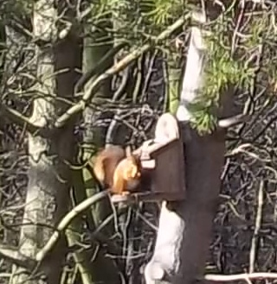
Return to the car park and head over to the Queen Elizabeth Park. Pause at the feeding station by the Railway Halt. It is common to see birds and red squirrels feeding there.

Watch their antics for a while as they get on with their lives.

What thoughts and feelings are your aware of as your watch and listen?

Follow the little railway off to the left and wander round towards the lake.

Look at how the recent plantings are becoming established on the site of one of the largest spoil heaps in Europe.

What does it teach you – about nature – about what God could do on your “waste” spaces?

Spend time walking around the lake – enjoying the tranquillity. There are busy roads close by and you might hear and see planes going overhead.

Be aware of the contrast and use thoughts from Ecclesiastes to help put some of them into words… you might make up your own.

Look at the wind turbines and think back to Woodhorn Pit.

Again, use Ecclesiastes to help you to reflect on times and seasons for everything.
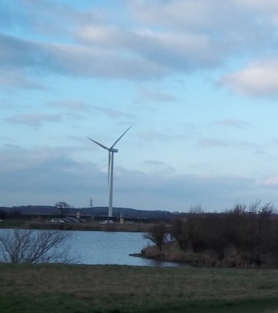
Reflect on the full quote: God has put a sense of past and future into their minds, yet they cannot find out what God has done from the beginning to the end.

Human beings are limited – we cannot see the fullness of what God is doing – only parts of it.

Reflect as you walk on where was God at work in your past.

Where is God in how things are in the present?

Where might God be leading us into the future?

We hope that you have enjoyed the Walk.

Text © Diocese of Hexham and Newcastle
Photographs © Kathryn Turner

